Sales Report Pipeline — Team Guide
Written 31 July 2026. It describes the system as it was on that day.

1. What this thing does
Picture a very fast, very literal post-room clerk: they know a handful of fixed instructions, carry them out perfectly, and stop dead the moment something is not exactly where the instructions say. That is this pipeline.
Every 15 minutes it checks the shared mailbox figures@dewynters.com for sales reports. It reads the numbers out of each one, renames the file to our standard format, files a copy in SharePoint and delivers the figures to the sales database over SFTP (a secure way to drop a file onto another computer, like a locked pigeonhole).
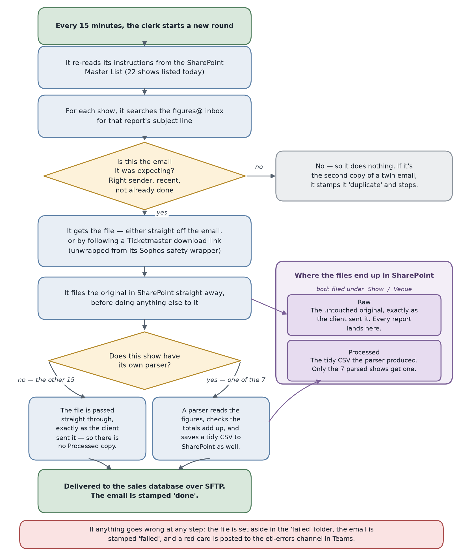
- What normal looks like: it runs every 15 minutes, and roughly 13 of every 15 runs find nothing new to do — that is the healthy resting state, not a fault.
- Every report email arrives twice, on purpose. One copy is processed, the other stamped sales_report_duplicate — the commonest thing in the logs.
- Filenames are deliberately dated one day behind the email, because it is the sales day. A file created on 31 July carries 30_07_2026. Correct, not a bug.

2. Checking on it — sign in, restart, find the error
Commands go in a terminal — a plain text window where you type an instruction and press Enter instead of clicking buttons (on a Mac, the app called Terminal). Paste one line, press Enter, wait, move on. Anything in angle brackets, like <your-username>, is a placeholder — swap in the real value before pressing Enter.

Signing in and looking around
- Connect to the VPN first. The machine is on our internal network and is not reachable from outside it.
- Sign in to the machine. SSH simply means signing in to another computer from your own, using your own personal username and password — like logging into a shared work laptop with your own account rather than one password the whole team shares.
ssh <your-username>@10.1.50.127
- Go to the right folder. cd means change directory. Every command below assumes you have done this first.
cd /opt/prefect/prod/code
- Check it is running. The pipeline sits in a container — a sealed box holding it and everything it needs to run, like a flight case packed once and moved as one unit. You want Up beside sales-report-extraction; Restarting means it is failing and retrying.
docker compose ps
- Restart it if it looks stuck and no code has changed. Mind the space in docker compose — docker-compose is not installed and will fail.
docker compose restart sales-report-extraction

Finding the error, in this order
- The Prefect dashboard in a browser. Click Runs in the left sidebar: newest first, green Completed, red Failed, blue Running. Click a run, then the Logs tab. Ignore anything stuck on Running from days ago — a harmless leftover.
http://10.1.50.127:4200
- The etl-errors channel in Teams. A failed report posts a red card headed Action Required: File Parsing Failed, Data Mapping Failed or System Error: Extraction Failed, naming the show, venue and rule, with a View Prefect Logs button that opens that run. Normal runs post their summary to etl-success instead; where that summary says “See Dev channel for details”, it means etl-errors.
- The log — the diary the pipeline writes as it works. Last 200 lines, then the live view (Ctrl+C stops watching). A WARNING line is not a failure; but if the opening line Environment variables loaded from /opt/prefect/prod/.env is missing, the pipeline crashed before it started — go to 3.1.
docker logs --tail 200 prefect-sales-extraction
docker logs -f --tail 50 prefect-sales-extraction
Watch the names: prefect-sales-extraction for docker logs, sales-report-extraction for docker compose — an easy slip to make.

How to be sure all is well
Teams only posts when a single report fails. A whole-run failure never posts to Teams at all — there is no alert for it, and nor does a dead container. A green Completed run can also contain one failed report; the line to read is the flow summary, e.g. Flow Summary: 2 successful, 0 failed. So always check the Prefect dashboard as well as Teams.

3. Common issues — the four that come up

3.1 A library needs updating
Looks like: either a rebuild stops on screen in red — ERROR: ResolutionImpossible — leaving the old container running, so the pipeline may still be fine; or the container will not stay up: Restarting in docker compose ps, ModuleNotFoundError in the log, no new runs at all.
Cause: one line in sales_report_extraction/requirements.txt names a package version that no longer fits the others — most likely paramiko>=3.0.0, the only line without a fixed version, so a rebuild can pull in a brand-new one.
Check first: the red ERROR: lines on screen, or docker logs --tail 200 for ModuleNotFoundError.

3.2 A parser breaks because a client changed their report format
A parser is the instruction card for reading one client's report — which column holds the ticket sales, which row holds the totals. Seven of the 22 shows have one.
Looks like: a red card naming one show and venue, headed Action Required: File Parsing Failed, with text starting Validation Failed:. That show is missing from the batch summary; everything else in the run lands normally.
Cause: the client renamed a column, moved the table, dropped the totals row or changed the file type, so the clerk's instruction card no longer matches what is in front of them.
Check first: the card names the exact column or row that went missing, e.g. 'Dominion Theatre' row not found. Compare the set-aside file in /opt/data/outlook_automation/data/failed with the previous day's version. The original stays untouched in SharePoint, so nothing is lost.
Parsers live in sales_report_extraction/src/parsers/. Use this table, not the filenames — one omits its show, and a similar spare file is not the live one.
Show | Venue | Report | Parser file
Devil Wears Prada | Dominion Theatre | Cumulative | nederlandaer_devil_wears_prada_cumulative_extraction_pdf.py
Silence of the Lambs Tour 2026 | Malvern Theatres | Advance | malvern_theatre_contractual_report_pdf_parser.py
Jesus Christ Superstar | Hong Kong | Advance | gmg_hk_jesus_christ_superstar_xlsx_parser.py
Jesus Christ Superstar | Taiwan | Advance | taiwan_jesus_christ_superstar_xlsx_parser.py
Jesus Christ Superstar | Manila | Advance | ticketek_event_settlement_excel_parser.py
Chicago Tour 2027 | Lugano | Advance | chicago_tour_lugano_parser.py
The Bodyguard 2025 | Sofia National Palace of Culture | Advance | the_bodyguard_tour_bulgaria_sofia.py

3.3 The machine goes offline, or its internet drops
Fully offline: ssh times out, the dashboard will not load, and Teams is completely silent — the thing that sends the Teams messages lives on the dead machine. This one needs IT: see 4.3.
Machine up, internet down: you can sign in, docker compose ps shows Up and the dashboard loads — but every run turns red every 15 minutes and Teams stays silent, because the alert needs the same broken connection. The log shows requests.exceptions.ConnectionError. Change nothing: it recovers by itself.

3.4 The Ticketmaster download link fails
Nine of the 22 shows get their file from a download link rather than an attachment — mostly Dublin Bord Gáis Energy Theatre shows, six of which share that venue, so one template change can break several at once.
Looks like: a red card, often for several Dublin shows at once, reading Could not find a valid Sophos/Ticketmaster download link in email body. or Failed to decode the Sophos wrapper link. — or 403 Client Error: Forbidden if the one-time link expired first.
Cause: the “Download Excel” link in the vendor's email could not be found, unscrambled or downloaded.
Check first: open the original email in figures@dewynters.com and click “Download Excel” yourself; if it has gone, the vendor changed their email. Also open the file in that show's SharePoint Raw folder — if it opens as a web page rather than a spreadsheet, the download fetched the wrong thing.

4. Making a fix
Step A — make a practice branch. A branch is a practice copy of the code (the repository: the shared store of the pipeline's files and their history) that you can experiment on without touching the live version. Replace <short-description> with a few real words, no spaces, e.g. hotfix/update-paramiko.
git checkout -b hotfix/<short-description>
Step B — rebuild: repack the container with your new code. A plain restart would re-run the old code, so any change to a .py file or requirements.txt needs this.
docker compose up -d --build sales-report-extraction
Step C — confirm. docker compose ps shows Up, not Restarting; the log shows the environment-variables line and no repeat of the error; and a new green Completed run appears within 15 minutes.

4.1 Fixing a library
- Step A: git checkout -b hotfix/<short-description>
- In sales_report_extraction/requirements.txt, change the one version — e.g. paramiko>=3.0.0 to paramiko==3.5.1. Choose from https://pypi.org/project/<package-name>/: the next release up from the version pinned, not the newest.
- Step B: docker compose up -d --build sales-report-extraction
- Step C. Confirm immediately — a library fault fails at startup, so there is no need to wait for a report.

4.2 Fixing a parser
- Step A: git checkout -b hotfix/<short-description>
- Open that show's file from the table in 3.2.
- Change the parser to match the new column, row or file type.
- Step B: docker compose up -d --build sales-report-extraction
- Step C, then test it with a real report — this fault only reappears when that report arrives. Forward the original email to figures@dewynters.com so a fresh copy lands on the next run.

4.3 When the machine is offline
- Confirm it is the machine: ssh times out, the dashboard will not load, and Portainer and the homepage are down too.
- Contact IT — the machine has to be brought physically back online. No branch, no rebuild.
- Once IT confirm it is back, sign in and restart the whole machine cleanly:
sudo reboot
- Wait two minutes, sign in again, then Step C. Nothing is lost: the next run re-checks 7 days of email.

4.4 Fixing the download link
- Step A: git checkout -b hotfix/<short-description>
- Open sales_report_extraction/src/link_extractor.py — a short file, and the whole story for this step.
- Compare it with the link in the vendor's current email and adjust it to match.
- Step B: docker compose up -d --build sales-report-extraction
- Step C, then test it with a real report, exactly as in 4.2.

5. Last resort — correcting an ID in SharePoint
The pipeline reads its instructions from the SharePoint list Sales Reporting - Master List - Automation - Python. Changes there need no restart and no rebuild — the list is re-read on the next run.
https://dewyntersltd.sharepoint.com/sites/SALESREPORTING/Lists/Sales%20Reporting%20%20Master%20List%20%20Automation%20%20Python/AllItems.aspx
- Find the right row. There are 22, and show names repeat — Jesus Christ Superstar alone has seven rows, one per venue. Match Show Name, VenueName and ReportType (Advance or Cumulative). LastRun cross-checks it: the most recently stamped row is live.
- Correct the field. Only ShowID, VenueID and DocumentID are safe to change: click in, type the correct whole number, save. VenueID is a text field, not a number field, so it accepts letters or a stray space without complaint — check it carefully.
- Whole numbers only — 180, never 180.5 (180 and 180.0 are both fine). This is the clerk at their most literal: a decimal raises no error and stops nothing. It quietly copies the wrong number out and sends a wrongly-named file onward, where it cannot be matched to the show — and nobody may notice for days.
- Leave every other column alone — especially SubjectKeyword, SenderDomain, ParserModule, ParserFunction and the Active tick box. If one of those is wrong or blank, the pipeline skips that show silently: no error, no Teams message, the report simply stops arriving.
These four cover almost everything that comes up. For anything else, the same routine — sign in, check it is running, restart, read the log — is always the right place to start.

NOT PART OF THE GUIDE — FOR THE DOCUMENT OWNER
Before sharing this — items to confirm
Two details could not be verified. They need filling in before this document goes to the team.
- [CONFIRM: how each person gets their sign-in password]
- [CONFIRM: whether lucillob and fij can run sudo reboot]
Access to fix as well: lucillob is not in the docker group and cannot reach /opt/prefect/prod/code (the folder permits alexc and fij only), so none of these commands will work for her yet.

